МИНИСТЕРСТВО ОБРАЗОВАНИЯ РЕСПУБЛИКИ БЕЛАРУСЬ

УЧРЕЖДЕНИЕ ОБРАЗОВАНИЯ

“БРЕСТСКИЙ ГОСУДАРСТВЕННЫЙ ТЕХНИЧЕСКИЙ УНИВЕРСИТЕТ”

**ИНТЕЛЕКТУАЛЬНЫЕ ИНФОРМАЦИОННЫЕ ТЕХНОЛОГИИ**

По лабораторной работе № __

__________________________________

Выполнил:

Студент группы ИИ-22

Копанчук Евгений Романович

Проверил:

________________

Брест – 202__

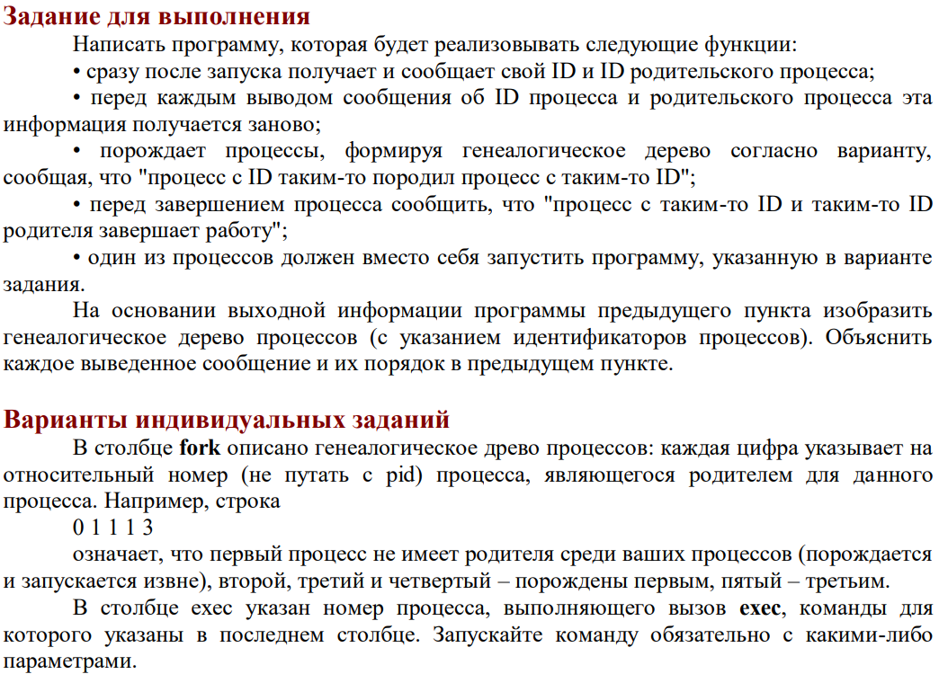



|  |  |  |
| --- | --- | --- |
| **Вывод программы:** |  | **Дерево процессов:** |
| FORK #1 PID = 11783 PPID = 11765  FORK #2 PID = 11784 PPID = 11783  FORK #4 PID = 11785 PPID = 11784  FORK #4 EXIT  FORK #5 PID = 11786 PPID = 11784  FORK #6 PID = 11787 PPID = 11786  FORK #7 PID = 11788 PPID = 11787  FORK #7 EXIT  FORK #6 EXIT  FORK #5 EXIT  FORK #2 EXIT  FORK #3 PID = 11789 PPID = 11783  bubunto_user  FORK #1 EXIT |  |  |

**Ход работы**

**Код программы:**

|  |
| --- |
| #include<sys/types.h>  #include<sys/wait.h>  #include<unistd.h>  #include<iostream>  using std::cout;  using std::endl;  int main() {  pid_t pid;  //Create 1st fork  cout << "FORK #1 PID = " << getpid() << " PPID = " << getppid() << endl;  //Create 2nd fork  if ((pid = fork()) == -1)  cout << "ERROR: fork #2 wasn't created." << endl;  else if (pid == 0) {  cout << "FORK #2 PID = " << getpid() << " PPID = " << getppid() << endl;  //Create 4th fork  if ((pid = fork()) == -1)  cout << "ERROR: fork #4 wasn't created." << endl;  else if (pid == 0) {  cout << "FORK #4 PID = " << getpid() << " PPID = " << getppid() << endl;  cout << "FORK #4 EXIT" << endl;  exit(0);  }  else wait(0);  //Create 5th fork  if ((pid = fork()) == -1)  cout << "ERROR: fork #5 wasn't created." << endl;  else if (pid == 0) {  cout << "FORK #5 PID = " << getpid() << " PPID = " << getppid() << endl;  //Create 6th fork  if ((pid = fork()) == -1)  cout << "ERROR: fork #6 wasn't created." << endl;  else if (pid == 0) {  cout << "FORK #6 PID = " << getpid() << " PPID = " << getppid() << endl;  //Create 7th fork  if ((pid = fork()) == -1)  cout << "ERROR: fork #7 wasn't created." << endl;  else if (pid == 0) {  cout<<"FORK #7 PID = "<<getpid()<<" PPID = "<<getppid()<<endl;  cout << "FORK #7 EXIT" << endl;  exit(0);  }  else wait(0);  cout << "FORK #6 EXIT" << endl;  exit(0);  }  else wait(0);  cout << "FORK #5 EXIT" << endl;  exit(0);  }  else wait(0);  cout << "FORK #2 EXIT" << endl;  exit(0);  }  else wait(0);  //Create 3th fork  if ((pid = fork()) == -1)  cout << "ERROR: fork #3 wasn't created." << endl;  else if (pid == 0) {  cout << "FORK #3 PID = " << getpid() << " PPID = " << getppid() << endl;  execl("/bin/whoami", "whoami", NULL);  }  else wait(0);  cout << "FORK #1 EXIT" << endl;  exit(0);  return 1;  } |

|  |
| --- |
| **Подготовка файла:** |
| bubunto_user@bubu:~$ cd ~/lab4  bubunto_user@bubu:~/lab4$ g++ -o main main.cpp  bubunto_user@bubu:~/lab4$ ./main |